30.64: (a) Initially the inductor blocks current through it, so the simplified equivalent circuit is
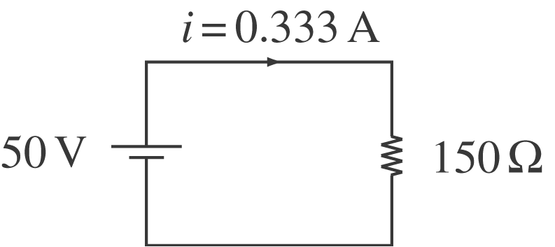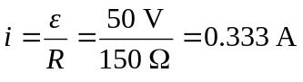
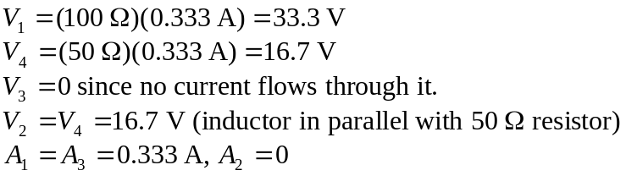
(b) Long after S is closed, steady state is reached, so the inductor has no potential drop across it. Simplified circuit becomes
